Matrix.h

/***************************************************************

* The interface file for the Matrix class. The only private *

* members are the sizes of the matrix and the pointer that *

* points to the matrix in the heap. *

* The constructor creates a matrix in the heap and the *

* destructor deletes the allocated memory in the heap. *

* The setup member function fills the matrices randomly *

* We have addition, subtraction, multiplication, and print *

* member functions. *

**************************************************************/

#include <iostream>

#ifndef MATRIX_H

#define MATRIX_H

#include <cmath>

#include <cstdlib>

#include <iomanip>

#include <cassert>

using namespace std;

// Matrix class definition

class Matrix

{

private:

int rowSize;

int colSize;

int** ptr;

public:

Matrix(int rowSize, int colSize);

~Matrix();

void setup();

void add(const Matrix& second, Matrix& result) const;

void subtract(const Matrix& second, Matrix& result) const;

void multiply(const Matrix& second, Matrix& result) const;

void print() const;

};

#endif

Matrix.cpp

#include "Matrix.h"

Matrix::Matrix(int rSize, int cSize)

{

rowSize = rSize;

colSize = cSize;

ptr = new int* [rowSize];

for (int i = 0; i < rowSize; i++) {

ptr[i] = new int[colSize];

}

}

Matrix::~Matrix() {}

void Matrix::setup()

{

for (int i = 0; i < rowSize; i++) {

for (int j = 0; j < colSize; j++) {

cin >> ptr[i][j];

}

}

}

void Matrix::add(const Matrix& second, Matrix& result) const

{

if ((this->colSize == second.colSize) && (this->rowSize == second.rowSize)) {

for (int i = 0; i < rowSize; i++) {

for (int j = 0; j < colSize; j++) {

result.ptr[i][j] = second.ptr[i][j] + ptr[i][j];

}

}

}

}

void Matrix::subtract(const Matrix& second, Matrix& result) const

{

if ((this->colSize == second.colSize) && (this->rowSize == second.rowSize)) {

for (int i = 0; i < rowSize; i++) {

for (int j = 0; j < colSize; j++) {

result.ptr[i][j] = ptr[i][j] - second.ptr[i][j];

}

}

}

}

void Matrix::multiply(const Matrix& second, Matrix& result) const

{

if (colSize == second.rowSize) {

for (int i = 0; i < rowSize; i++) {

for (int j = 0; j < second.colSize; j++) {

int mul = 0;

for (int z = 0; z < colSize; z++) {

mul += ptr[i][z] * second.ptr[z][j];

}

result.ptr[i][j] = mul;

}

}

}

}

void Matrix::print() const

{

for (int i = 0; i < rowSize; i++) {

for (int j = 0; j < colSize; j++) {

cout << ptr[i][j] << ' ';

}

cout << endl;

}

}

main.cpp

/**************************************************************

* We create several matrix objects in the heap and we apply *

* some operations on them. *

**************************************************************/

#include "matrix.h"

int main()

{

// Instantiation and setup of matrix1

cout << "matrix1" << endl;

Matrix matrix1(3, 4);

matrix1.setup();

matrix1.print();

// Instantiation and setup of matrix2

cout << "matrix2" << endl;

Matrix matrix2(3, 4);

matrix2.setup();

matrix2.print();

// Instantiation and setup of matrix3

cout << "A new matrix3" << endl;

Matrix matrix3(4, 2);

matrix3.setup();

matrix3.print();

// Adding matrix2 to matrix1 and printing the result

cout << "Result of matrix1 + matrix2" << endl;

Matrix addResult(3, 4);

matrix1.add(matrix2, addResult);

addResult.print();

// Subtracting matrix2 from matrix1 and printing the result

cout << " Result of matrix1 - matrix2" << endl;

Matrix subResult(3, 4);

matrix1.subtract(matrix2, subResult);

subResult.print();

// Multiplying matrix1 and matrix3 and printing the result

cout << "Result of matrix1 * matrix3" << endl;

Matrix mulResult(3, 2);

matrix1.multiply(matrix3, mulResult);

mulResult.print();

return 0;

}

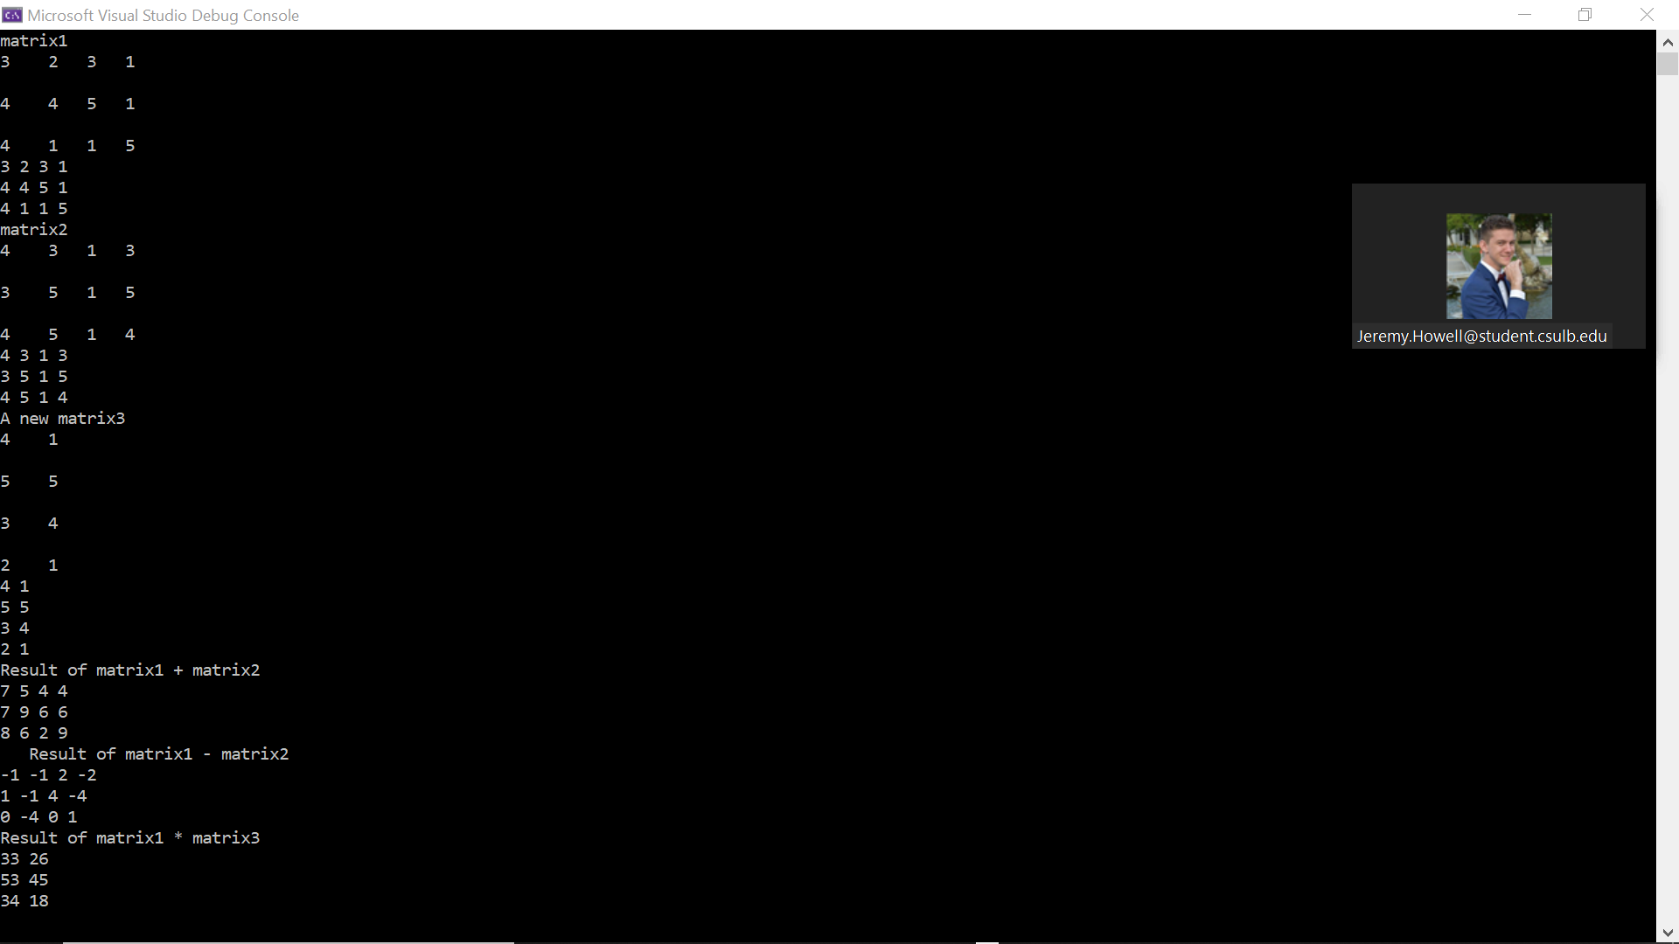

Demonstrated at 11:10am on 09/21/2021